**REPORT: VIKSIT BHARAT @2024**

**NAME OF THE EVENT: AWARENESS/ COUNSELING PROGRAMME ON VIKSIT BHARAT @2024**

**DATE: 13-12-2023**

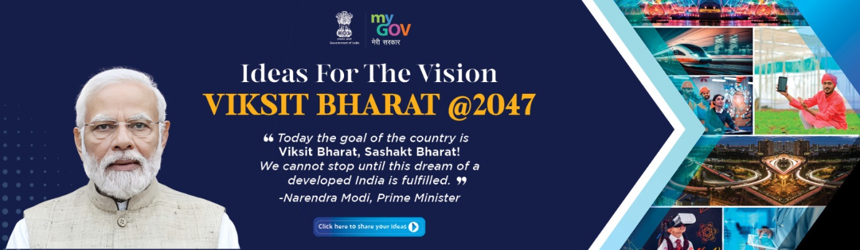

The Department of English organized a one day awareness and counseling programme on Viksit Bharat@2024 on 13th December, 2023 in the Innovation and Incubation center of the college at 12:30 PM. The event was attended by the faculty of the concerned department and 65 students.

Prof Irfana Rasool, Head Department of English initiated the proceedings of the event. She spoke at length about the Viksit Bharat @2047: Voice of Youth, launched by the Prime Minister, Shri Narendra Modi on 11th of December. She spoke at length about the grand vision for a progressive India upheld by the campaign. She impressed upon the students to come forward with their innovative ideas and participate enthusiastically in the Government of India’s programme.

Prof. Alima Mudasir, faculty from the Department of English gave a detailed outline of the programme. She spoke about the main highlights of the progarmme and simplified the process for the students.

The event concluded with question/answer session during which students clarified their doubts with respect to the Viksit Bharat @2024 campaign. Dr. Showkat coordinated the on the spot registration of the students on the Viksit Bharat portal.

