**REPORT: VIKSIT BHARAT @2024**

**NAME OF THE EVENT: EXTEMPORE SPEECH COMPETITION ON “VIKSIT BHARAT: A VISIONARY DREAM”**

**DATE: 14-12-2023**

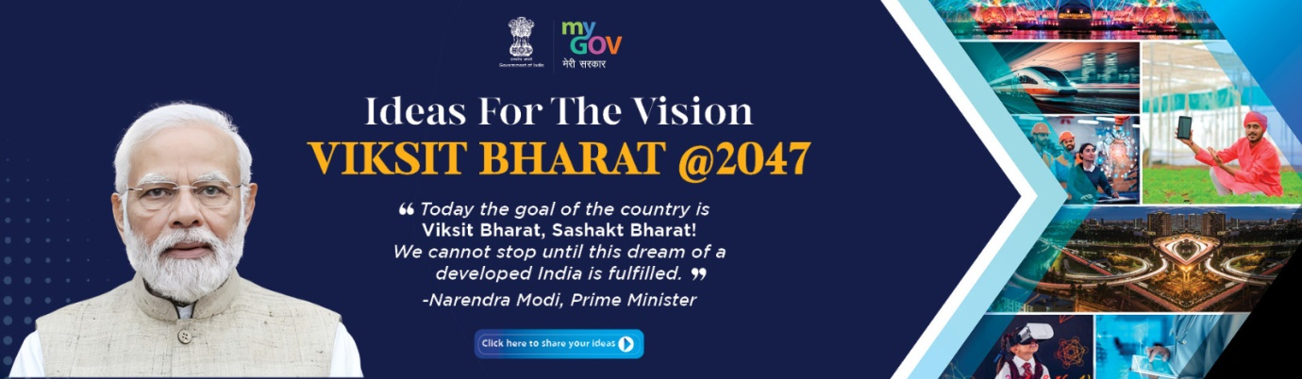

In line with the Prime Minister’s vision to actively involve the students of Higher Education Department in the formulation of national plans, priorities and goals of the country and in accordance with the ‘Viksit Bharat @2047: Voice of Youth’ initiative, the Department of English organized a extempore speech competition on “Viksit Bharat: A Visionary Dream” on 14th December in the Innovation and incubation Centre of the college. The programme was organized to provide a platform to the youth of the country to contribute ideas to the vision of Viksit Bharat @2047.

The programme was attended by faculty from the Department of English and students of the college. 12 student speakers participated in the programme and spoke vehemently about the vision behind Viksit Bharat.

Prof. Irfana Rasool, Head Department of English welcomed the students and the faculty present on the occasion. She explained the need to organize such programmes as essential steps towards initiating the process of engaging youth to share their ideas and suggestions for Viksit Bharat @2047.

Prof. Alima Mudasir and Prof. Laila Khalid acted on the jury during the programme and evaluated the speakers on the basis of their content, language and presentation skills. The proceedings of the event were conducted by Dr. Showkat.

