**REPORT: VIKSIT BHARAT @2024**

**NAME OF THE EVENT: IDEA EXCHANGE/ GROUP DISCUSSIION: VIKSIT BHARAT @2024**

**DATE: 15-12-2023**

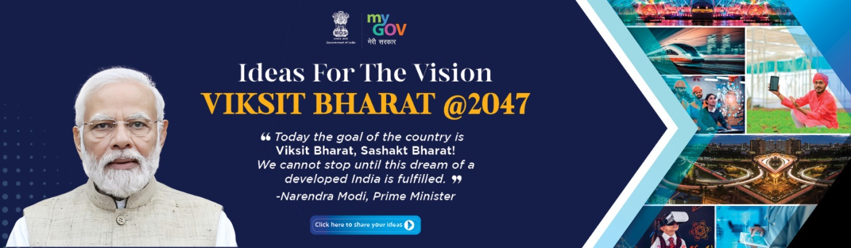

The Debate and Seminar Committee and the Department of English collectively organized group discussion among the students of the Department as a part of the series of events being organized in connection with Viksit Bharat @2024 campaign. The programme was organized on 14th December, 2023 in the Innovation and Incubation Cell and was attended by 50 students.

Dr. Nadia Shah gave a brief outline of the programme and primed the participating students about the nature of the programme.

Participating students were divided into groups of 4-5 and each group was assigned a mentor from the Department who briefed them about the Viksit Bharat campaign. Students engaged in extensive brainstorming session for one hour. The exercise was conducted to generate innovative ideas and seek healthy suggestions so that students are prepared for the Innovation fest, the central pillar of Viksit Bharat campaign. 