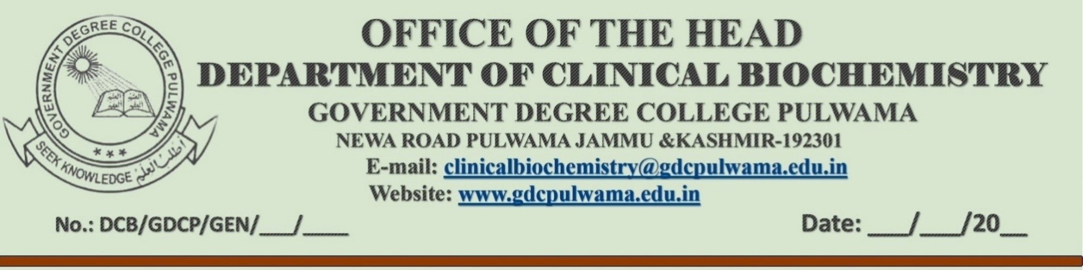
DCB/GDCP/CLB/21
18 /12/2023

NOTICE

Subject: Workshop on Virtual Labs in the Department of Clinical Biochemistry

Dear Students
The Department of Clinical Biochemistry, in collaboration with the Department of Computer Applications, is pleased to announce an upcoming Workshop on Virtual Labs. This workshop aims to provide students with remote access to simulation-based labs facilitated by the virtual lab platform of IIT Bombay. The goal is to spark curiosity among students, encouraging them to actively participate in experiments and thereby deepen their understanding of fundamental and advanced concepts through remote experimentation. The session is anticipated to be both captivating and educational for all participants.

Details of the workshop are as follows:

Date: 19th December 2023
Time: 11:30 AM
Venue: Workstation, Department of Computer Applications

Agenda:
- Introduction to Virtual Labs in Clinical Biochemistry
- Application of Virtual Labs in Experiments
- Hands-On Training Session
- Q & A Session

Note: Attendance for this workshop is MANDATORY and will be considered as part of your overall practical attendance. Your active participation is crucial for maximizing the benefits of this valuable learning opportunity.
We look forward to your enthusiastic participation in this engaging and educational session.

Best Regards,

H.O.D
Clinical Biochemistry

